|  |  |  |  |
| --- | --- | --- | --- |
| Quote ref: DBLB20248 | | | Date |
| Sl no | Equipment name | Short discription | Image (Ref images/ may change due to revisied models) |
| 1 | Li-ion cell testing lab 5V12A 8Ch | Input Power 826 W  Input AC 220V/110V ±10% / 50Hz  Voltage CV Output Range 25mV-5V  Output range/channel: Range1: 5mA-1A; Range2: 1A-6A; Range2: 6A-12A CV cut-off current: Range1: 2mA; Range2: 12mA; Range3: 24mA  Power Per Channel Output Power 60 W Min data recordinterval:100ms  Min voltage change:10mV  Min current change: 2mA; 12mA; 24mA Data recording Frequency: 10Hz  Voltage and Current Testing Sample 4-wire connecting Max cycles 65535 |  |
| 2 | IMPEDANCE ANALYZER (1 mHz to 200  kHz) | Measurement modes LCR mode, Continuous measurement mode (LCR mode / Analyzer mode), Analyzer mode (Sweeps with measurement frequency and measurement level, temperature characteristics, equivalent circuit analysis)  Measurement parameters Z, Y, θ, Rs (ESR), Rp, Rdc (DC resistance), X, G, B, Cs, Cp, Ls, Lp, D (tanδ), Q, T, σ (conductivity), ε (dielectric constant)  Measurement range 100 mΩ to 100 MΩ, 10 ranges (All parameters are determined according to Z)  Display range Z, Y, Rs, Rp, Rdc, X, G, B, Ls, Lp, Cs, Cp, σ, ε :  ±(0.00000 [unit] to 9.99999G [unit], Absolute value display for Z and Y only  θ : ±(0.000° to 180.000°), D : ±(0.00000 to 9.99999)  Q : ±(0.00 to 99999.9), Δ % : ±(0.0000% to 999.999%)  T : -10.0°C to 99.9°C  σ, ε :±(0.00000f [unit] to 999.999G [unit] Basic accuracy Z: ±0.05% rdg. θ: ±0.03°  Measurement frequency 1 mHz to 200 kHz (5 digits setting resolution, minimum resolution 1 mHz)  Measurement signal level Normal mode:  V mode/CV mode: 5 mV to 5 Vrms, 1 mVrms steps CC mode: 10 µA to 50 mArms, 10 µArms steps Low impedance high accuracy mode:  V mode/CV mode: 5 mV to 2.5 Vrms, 1 mVrms steps CC mode:10 µA to 100 mArms, 10 µArms steps  Output impedance Normal mode: 100 Ω, Low impedance high accuracy mode: 25 Ω Display 5.7-inch color TFT, display can be set to ON/OFF  Measurement time 2 ms (1 kHz, FAST, display OFF, representative value)  Functions DC bias measurement, DC resistance temperature compensation (converted reference temperature is displayed), Temperature measurement, Battery mesurement (Automatic DC biasing system), Comparator, BIN measurement (classiﬁcation), Panel loading/saving, Memory function  Interfaces EXT I/O (Handler), USB communication (high-speed), USB memory Optional: Choose 1 from RS-232C, GP-IB, or LAN  Power supply 100 to 240 V AC, 50/60 Hz, 50 VA max.  Dimensions and mass 330 mm (12.99 in) W × 119 mm (4.69 in) H × 168 mm (6.61 in) D, 3.1 kg  (109.3 oz) |  |
| 3 | 100 Cells for testing | NMC 18650 (Cylindrical)  NMC 21700 (Cylindrical)  NMC 26650 (Cylindrical) NMC 96 AH (Prismatic) NMC (Pouch)  LFP (Cylindrical) LFP (Cylindrical) LFP (Cylindrical) LFP (Prismatic) |  |
| 4 | Fixture for cell testing | Jig for 10 mAmp Coin cell  Jig for 30 Amp Cylindrical & Prismatic Jig for 100 Amp Prismatic  Jig for Pouch cells  Special Cylindrical Jig for ACIR testing Extension for thermal testing of cells |  |

|  |  |  |  |
| --- | --- | --- | --- |
| 5 | Li-ion pack testing 99V 10A Charging 20 A discharging 1Ch | Power Supply: AC 220V±10% 50/60HZ Basic Function: Charge  Discharge Auto-cycle  Test data analysis  Test data import & export  Applicable Batteries: Lead-acid battery pack Li-ion battery pack  Battery Rated Voltage: 12V-84V CHARGE Charge Methods: CV & CC  Charge Current: 0.5-10A adjustable, 0.1A stepping Charge Cut-Off Current: 0.1-5A adjustable, 0.1A stepping Charge Voltage Range: 9V-99V, 0.1V stepping  Charge Current Accuracy: ±0.03A Charge Voltage Accuracy: ±0.1V  DISCHARGE Discharge Methods: CC  Discharge Current: 9V-21V: 0.5-10A adjustable 21V-99V: 0.5-20A adjustable  Discharge Cut-Off Voltage 9V-99V, 0.1V stepping Discharge Current Accuracy: ±0.03A  Discharge Voltage Accuracy: ±0.1V Max. Cycle Index: 16 times  Operation Methods: Software/Panel  Battery Connection Methods: Testing cable with clamp Communication Port: LAN  Product Size: 45*36*14.5 CM Product Weight: 9 KGS |  |
| 6 | Pack ACIR testing lab 60V 1Ch | Resistance measurement ranges 3 mΩ（Max. display: 3.1000 mΩ, resolution: 0.1 µΩ, measurement current: 100 mA）  30 mΩ（Max. display: 31.000 mΩ, resolution: 1 µΩ, measurement current: 100 mA）  300 mΩ（Max. display: 310.00 mΩ, resolution: 10 µΩ, measurement current: 10 mA）  3 Ω（Max. display: 3.1000 Ω, resolution: 100 µΩ, measurement current: 1 mA）  30 Ω（Max. display: 31.000 Ω, resolution: 1 mΩ, measurement current: 100 µA）  300 Ω（Max. display: 310.00 Ω, resolution: 10 mΩ, measurement current: 10 µA）  3 kΩ（Max. display: 3.1000 kΩ, resolution: 100 mΩ, measurement current: 10 µA）  Basic accuracy: ±0.5% rdg ±10 dgt（3 mΩ range）, ±0.5% rdg ±5 dgt（30 mΩ range or more） Measurement frequency: 1 kHz ±0.2 Hz  Measurement method: AC four-terminal method  Voltage measurement ranges 6 V（Max. display: 6.00000 V, resolution: 10 µV） 60 V（Max. display: 60.0000 V, resolution: 100 µV）  100 V（Max. display: 100.000 V, resolution: 1 mV）  Basic accuracy: ±0.01% rdg. ±3 dgt. Response time 10 ms  Sampling period Ω or V (60 Hz): 4 ms (EX.FAST), 12 ms (FAST), 35 ms (MEDIUM), 150 ms (SLOW)  ΩV (60 Hz): 8 ms (EX.FAST), 24 ms (FAST), 70 ms (MEDIUM), 253 ms (SLOW)  Ω or V (50 Hz): 4 ms (EX.FAST), 12 ms (FAST), 42 ms (MEDIUM), 157 ms (SLOW) ΩV (50 Hz): 8 ms (EX.FAST), 24 ms (FAST), 84 ms (MEDIUM), 259 ms (SLOW)  Functions Contact check, Zero adjustment (±1000 counts), Pulse measurement, Comparator (Hi/ IN/ Lo), Statistical calculations (Max. 30,000), Delay, Average, Panel saving/loading, Memory storage, LabVIEW® driver  Interfaces LAN (TCP/IP, 10BASE-T/100BASE-TX)  RS-232C (Max. 38.4 kbps, Available as printer I/F) EXT I/O (37-pin Handler interface)  Analog output (DC 0 V to 3.1 V)  Power supply 100 to 240 V AC, 50 Hz/60 Hz, 35 VA max.  Dimensions and mass 215 mm (8.46 in) W × 80 mm (3.15 in) H × 295 mm (11.61 in) D, 2.4 kg  (84.7 oz)  Included accessories Instruction manual ×1, Power cord ×1, Operating Precautions ×1 |  |
| 7 | Li-ion battery packs for testing | Cylindrical cell based  NMC 14S 1P (5Ah) NMC 14S 2P (10 Ah)  LFP 15S 1P (5Ah) LFP 15S 2P (10 Ah) |  |
| 8 | Jigs, wiring & ﬁxture for testing | Terminal leads for Pack connection for all packs from thermal chamber to bench Safety enclosure for each pack  Pack storage trays Pack balancer circuit |  |

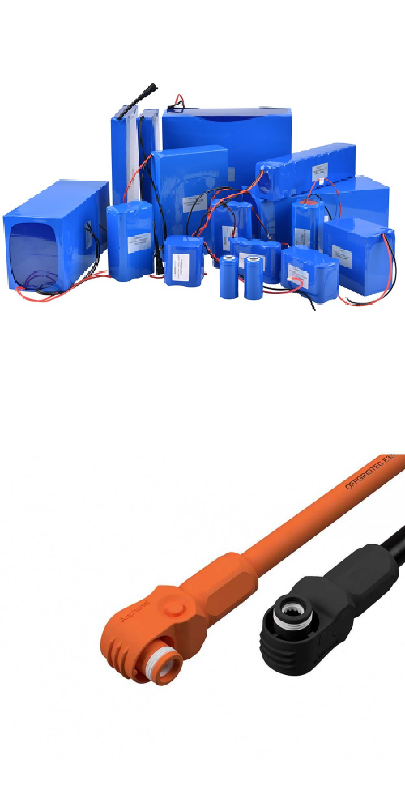

|  |  |  |  |
| --- | --- | --- | --- |
| 9 | Environmental chamber (-10 to +70 Deg Cel) | Material of Construction Inside Stainless Steel and Outside Stainless Steel. Insulation PUF Insulation.  Air Circulation Forced air circulation for uniform temp by suction blower with fan Observation Door Inside observation Acrylic / glass door.  Handle / hinges  Handle and hinges for positive  Sealing with lock and key arrangement.  Port Hole Both Side Port Hole with rubber seal to insert sensors. Lighting Interior illumination for working area.  Heating System Tubular ﬁnned type heaters for dry and wet both.  Humidity System Steam injection Humidity derived by dry and wet bulb principle Refrigeration System Emerson make or equivalent evaporation coil and fan cooled condenser Control System HMI/PLC with pen Drive System & Printer Attachment  (7” HMI with colour touch screen.) Programmable Ramp /Soak Type  Total Program 10 Nos. & Each Program 20 Steps. Number of Cycle 999  Sensor Sensor R.H. / Temperature Safety Features   1. Float switch to cut off the mains supply in case of low water level in the boiler tank. 2. Safety Thermostat in evaporation tray to cut off Heater supply in case of low water level. 3. Dedicated safety controller / Thermostat with separate sensor to Cut off the supply in case of overshoot and undershoot of Temperature giving audio visual alarm. 4. 2 min. compressors ‘ON’ delay timer to safe guard The compressor.   Trays Adjustable type, Rod trays – 03 Nos.  Finish Internal Mirror Polish, External Powder Coated (from Both surface)  Other  Castor wheels, MCB, Adjustable Tray Height Arrangement. Heavy duty latch with lock & key & hinges.  Power Works on 230 V AC single phase 50 Hz.  Material of Construction Inside Stainless Steel and Outside Stainless Steel. Insulation PUF Insulation.  Air Circulation Forced air circulation for uniform temp by suction blower with fan Observation Door Inside observation Acrylic / glass door.  Handle / hinges  Handle and hinges for positive  Sealing with lock and key arrangement.  Port Hole Both Side Port Hole with rubber seal to insert sensors. Lighting Interior illumination for working area.  Heating System Tubular ﬁnned type heaters for dry and wet both.  Humidity System Steam injection Humidity derived by dry and wet bulb principle Refrigeration System Emerson make or equivalent evaporation coil and fan cooled condenser Control System HMI/PLC with pen Drive System & Printer Attachment  (7” HMI with colour touch screen.) Programmable Ramp /Soak Type  Total Program 10 Nos. & Each Program 20 Steps. Number of Cycle 999  Sensor Sensor R.H. / Temperature  EXPERT EQUIPMENTS The Scientiﬁc Automation Company. GST NO. - 27APUPP1653D1ZM  Speciﬁcation:  GMP Model Inside S. S. 304 mirror polished & Outside S. S. 304 matt polished. Temp Range -20 deg C to +80 Deg C  Humidity Range 30% to 85% Rh Temperature Accuracy ± 0.2 Deg C Temperature Uniformity ± 1 Deg C Humidity Accuracy ± 2% RH and better Rh  Inner SIZE WDH (cm): 50 X 50 X 80 (200 Lit.) |  |
| 10 | 5 units of single cell BMS algorithm Development Lab - |  |  |
| 11 | 5 units of single cell multicell BMS algorithm Development Lab - 14S |  |  |
| 12 | BMS algorithm Software Package | Industry ready calibrated BMS algorithm Model based with Matlab  MBD standards complient MIL, SIL, PIL testing complient  Ready for codegeneration & deployment SOC algorithm  SOH algorithm  Cell balancing algorithm Safety interlocks |  |